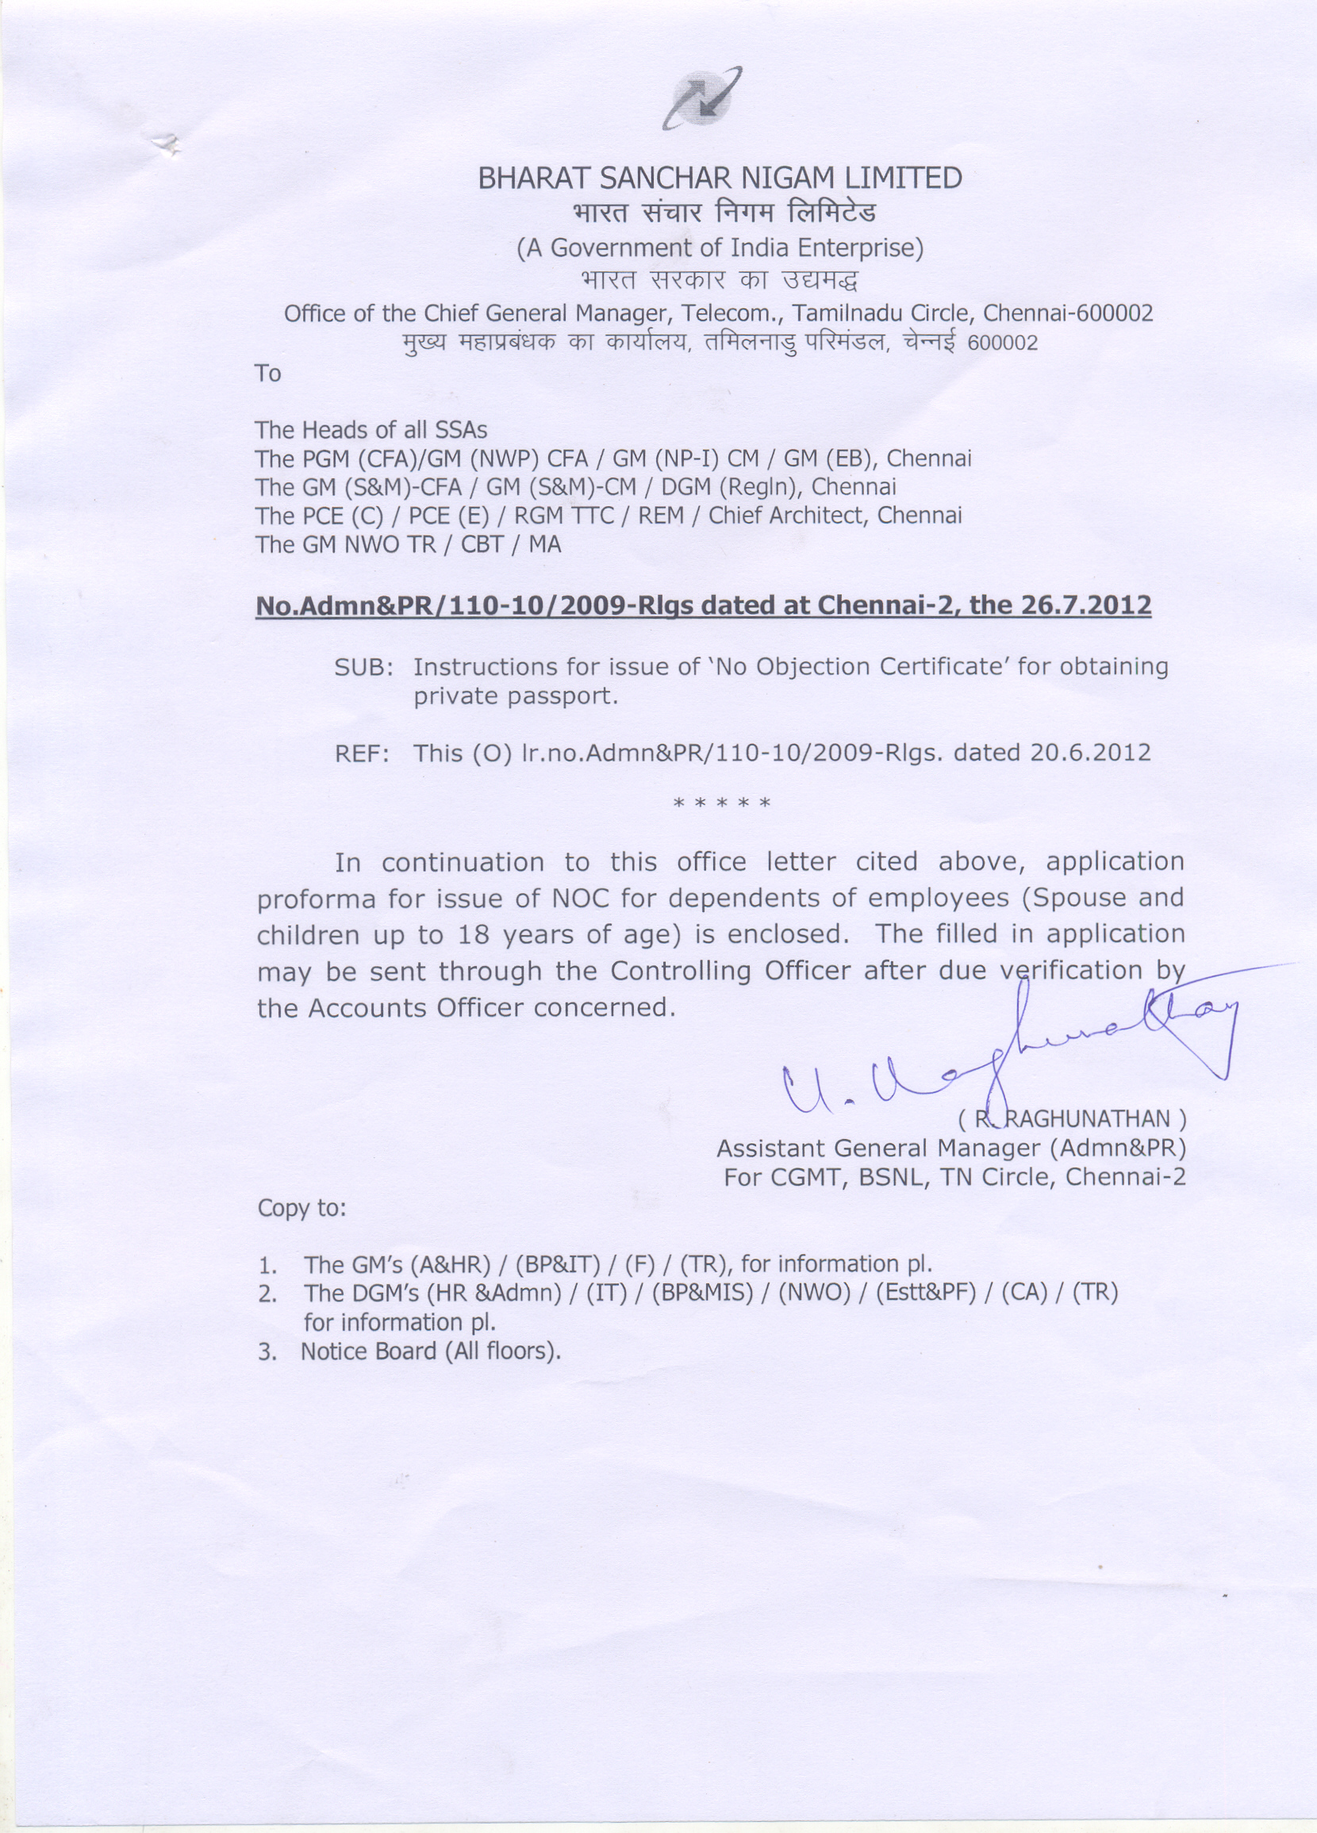

APPLICATION FOR ISSUE OF NOC TO DEPENDENTS OF EMPLOYEES (Spouse/Children up to 18 years of age) FOR OBTAINING PASSPORT

- DETAILS OF EMPLOYEE :

1. Name of the official : _ _ _ _ _ _ _ _ _ _ _ _ _ _ _ _ _ _ _ _

2. HRMS Number : _ _ _ _ _ _ _ _ _ _ _ _ _ _ _ _ _ _ _ _

3. Name of Father/Husband : _ _ _ _ _ _ _ _ _ _ _ _ _ _ _ _ _ _ _ _

4. Present office address in full : _ _ _ _ _ _ _ _ _ _ _ _ _ _ _ _ _ _ _ _

_ _ _ _ _ _ _ _ _ _ _ _ _ _ _ _ _ _ _ _

5. Post held : _ _ _ _ _ _ _ _ _ _ _ _ _ _ _ _ _ _ _ _

6. Whether temporary/Permanent : _ _ _ _ _ _ _ _ _ _ _ _ _ _ _ _ _ _ _ _

7. Date of confirmation in the entry cadre : _ _ _ _ _ _ _ _ _ _ _ _ _ _ _ _ _ _ _ _

- DETAILS OF DEPENDENT FOR WHOM NOC IS REQUIRED :

1. Name of the dependent : _ _ _ _ _ _ _ _ _ _ _ _ _ _ _ _ _ _ _ _

2. Relationship : _ _ _ _ _ _ _ _ _ _ _ _ _ _ _ _ _ _ _ _

3. Date of Birth / Age : _ _ _ _ _ _ _ _ _ _ _ _ / _ _ _ _ _ _ _

4. Occupation : _ _ _ _ _ _ _ _ _ _ _ _ _ _ _ _ _ _ _ _

5. Whether details of the dependent has
been recorded in service records ? : _ _ _ _ _ _ _ _ _ _ _ _ _ _ _ _ _ _ _ _

6. Whether 2 photographs attached ? : _ _ _ _ _ _ _ _ _ _ _ _ _ _ _ _ _ _ _ _

7. Whether NOC obtained earlier, if so give
details : _ _ _ _ _ _ _ _ _ _ _ _ _ _ _ _ _ _ _ _

I hereby declare that the statements given in the application are true to the best of my knowledge and belief and that the person for which medical expenses are incurred in wholly dependent on me I hereby declare that the statements given above are true to the best of my knowledge and belief and that the person for whom NOC is required is wholly dependent on me.

Date: Signature of the employee
Phone/Mobile No.
- - - - - - - - - - - - - - - - - - - - - - - - - - - - - - - - - - - - - - - - - - - - - - - - - - - - - - - - - - - - - - - - - - - - - - - - - - - - -
NOTE: Above application & photograph of the dependent should be verified with service records and certified by the Accounts Officer concerned, before forwarding.

Endt. No. _ _ _ _ _ _ _ _ _ _ _ _ _ _ _ _ _ _ _ _ _ _ _ _ _ _ _ _ _ _ _ _ _ _ dated _ _ _ _ _ _ _

Verified and forwarded to _ _ _ _ _ _ _ _ _ _ _ _ _ _ _ _ _ _ _ _ _ _ _ _ _ _ _ _ _ _ _ _ _ _ _ _ for further necessary action.

Signature of Accounts Officer Signature of the Controlling Officer ^{(Seal)} ^{(Seal)}

